Pathfinder2e Import Instructions

Getting the JSON information from the Pathbuilder2 App
- Open the pathbuilder app on the device
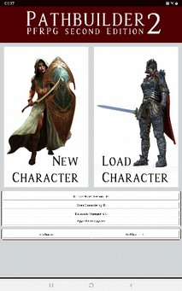

- Load the character that needs importing
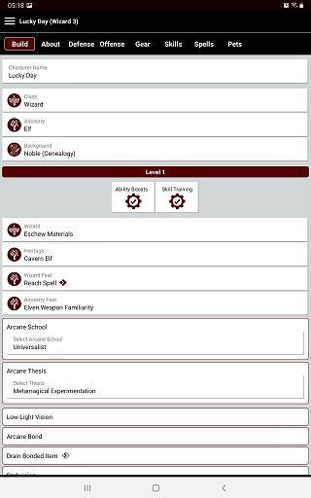

- Open the Pathbuilder2e Menu --> Select Export Characters → Select Export to Foundry VTT → Select view JSON file
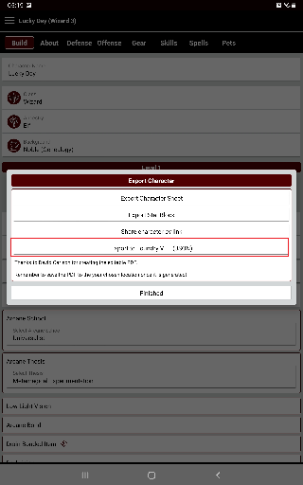

Highlight the JSON content (gently press the screen with your finger at the bottom of the device and when a blue highlighter is displayed, move your finger gently to the top of the screen
Press “Select all” (this will highlight all the JSON contents)
Press “Copy” (this will cache the highlighted contents)
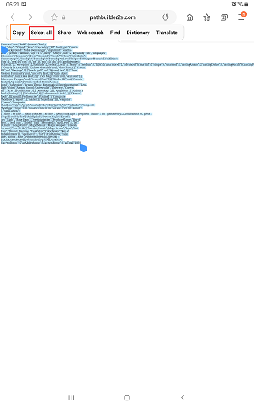

Open something that can be used to transfer the content (These instructions will use email drafts until a better solution presents itself)
Open the email, Compose email → Select the body of the email ->Paste the content captured into the draft
Save the draft (Gmail automatically saves drafts, hopefully other email services do the same …)
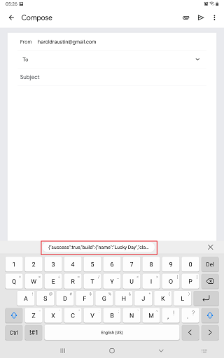

Import the JSON from the email to Roll20 Character Sheet
Open the email drafts to collect the JSON data structure (thingy).
Click the email body, select all the contents (ctrl+A), copy the contents (ctrl + c)
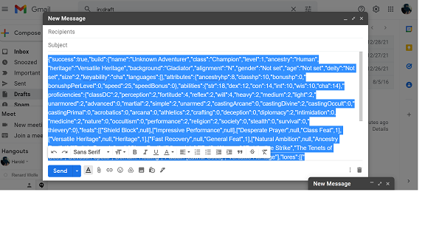

Open Roll20 Virtual Table top containing the API for the PathBuilder2 character import. During testing the following link will be active: https://app.roll20.net/join/12148361/vmUuzQ
Create a character sheet by typing “!charsheet” in the chat, without the double quotes.
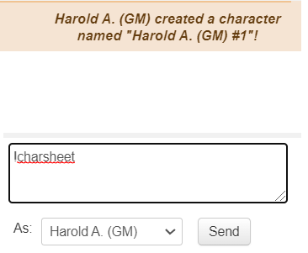

Click Journal button, above the chat window


Open the character sheet → click Character Sheet tab → click Details button
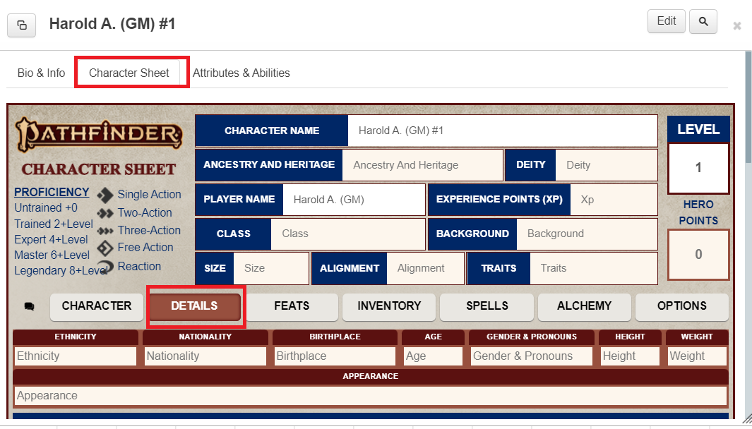
Scroll down to Campaign Notes, then add the JSON in the Notes section.
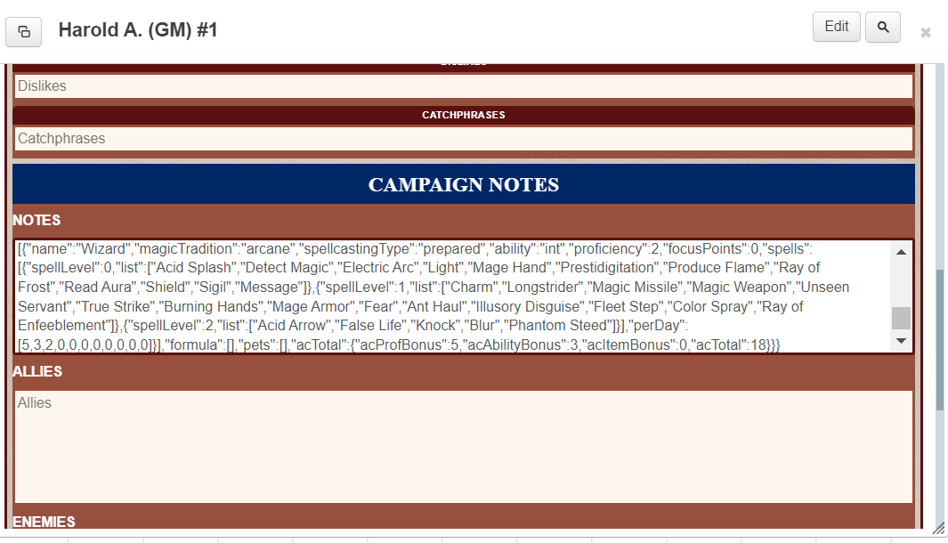
Go back to the chat window ..
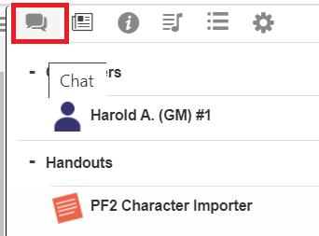

Type “!importPF2” without the double quotes.
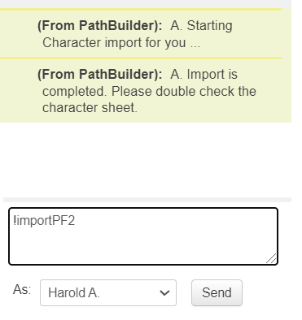
Once the importing is completed. Verify the data looks correctly.
If there are issues with the data mapping, add a note of the issue in the Character Bio & Info box on the edit tab (the place where the character goes)
1) The field name (and location)
2) the current field value
3) expected field value

